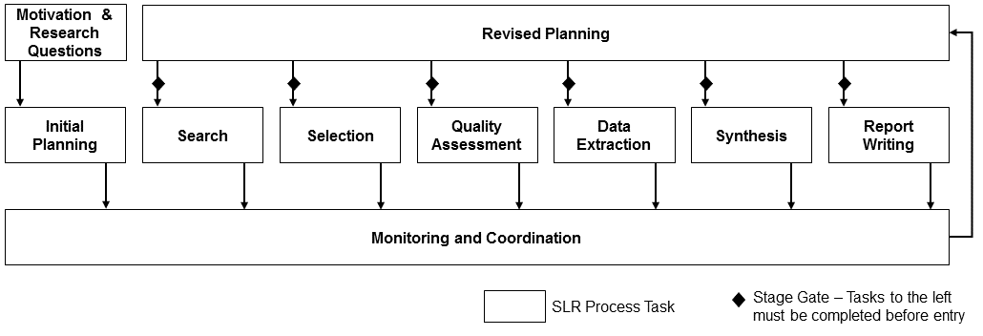

**Principle 1: Automate the SLR process to reduce manual labor and allow for iteration.**

1. Support task automation – substitute algorithmic and computer cycles for human work
2. Support automated guidance (phase protocol execution support)
3. Support iteration within and among SLR Phases

**Principle 2: Facilitate collaboration.**

1. Support project collaboration and coordination of work teams
   1. comprised of multiple researcher
   2. geographically dispersed
   3. working asynchronously
2. Support monitoring of progress and quality
3. Support revised planning

**Principle 3: Store data to support reuse and evolution.**

1. Support future extensions through persistence of SLR templates and data
2. Support data interchange across all SLR phases

**Principle 4: Provide an open architecture with extensible design.**

1. Support existing and future tools through workflow integration and data interchange
2. Support open architecture